John Livesay Speakers Bureau Kit

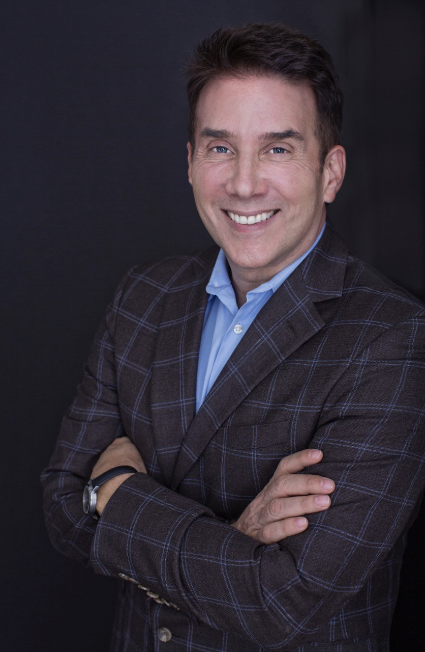
Photo

Bio
The Short:
Sales speaker John Livesay, aka “The Pitch Whisperer,” helps sales forces connect with today’s crazy-busy, ultra-savvy buyers by becoming master storytellers with magnetic pitches. Whoever tells the best story gets the sale, and after John speaks, your people will know exactly how to craft irresistible stories.
The Long:
John Livesay is known as “The Pitch Whisperer.” He helps salespeople become magnetic storytellers with the ability to make irresistible offers to their ideal clients.
As a keynote speaker, John has captivated audiences in settings ranging from Gensler’s top management retreat to Coca-Cola’s CMO Summit. He is also the author of The Successful Pitch: Conversations On Going From Invisible To Investable and the host of “The Successful Pitch” podcast, which is heard in over 60 countries.
John has appeared on TV (CBS, FOX and ABC) as the expert on “How To Ask For What You Want And Get A Yes.” Audiences love him because they know he’s been in their shoes. During a 20-year career in media sales with Conde Nast, John worked across all 22 brands in their corporate division, and was the recipient of salesperson of the year honors.
John currently lives in Los Angeles with his two King Charles Spaniels who welcome him home after he returns from his keynote talks, reminding him of the importance of belly rubs. He is an active supporter of Project Angel Food, which delivers food to people who are homebound with critical illness.

Key Outcomes
John’s program attendees will:
- Learn the secrets of master storytellers to develop an emotional connection with their existing and prospective clients
- Learn a proven strategy to craft a sales presentation that is memorable and makes the clients go from skeptical to "Gotta Have It"
- Learn how to have more confidence, connection, and commitment in every interaction
- Learn how to replace "pitches" with collaborative conversations so you and your buyer become co-pilots

Client Logos

Testimonials
“We’ve won over $5 million in new business thanks to the storytelling skills John shared with our people!” — Gensler Architecture
“We invited John to be the keynote speaker for our development retreat… he set an inspiring tone for the rest of the day.” — KPBS San Diego
“We feel so lucky to have had you speak to us about the art of selling. You equipped us with the tools to be our own best advocates. Everyone left feeling inspired – I sure did!” — The Editor-At-Large Magazine

Video
https://www.youtube.com/watch?v=E7b6k1TfmrM

Available Presentations

From Invisible To Irresistible
Today’s buyers are crazy-busy and ultra-savvy, which means yesterday’s sales strategies fall flat and leave your salespeople easily forgettable. How can you stand out with new competitors and new technologies disrupting the marketplace every day?
The sales people who Get To YES are those who become master storytellers with magnetic pitches. Whoever tells the best story gets the sale, and after John speaks, your people will know exactly how to craft irresitible stories.
Before John leaves the stage, your people will be inspired and equipped to…
- Utilize Empathy Skills That Win Clients
- Find Their Own Stories To Create Real Connections with Your Ideal Clients
- Leverage New Ways to Use Silence to Get to YES

Secret Strategies To Win Back Clients
Do you feel like you need the tools of a hostage negotiator to win back a client?
Do you feel that a door is closed forever with one of your top clients that left?
Do you feel confused, frustrated, and even angry that one of your best clients left you?
Bill Gates once said, “Your most unhappy customers are your greatest source of learning.” If 20% of your clients generate 80% of your revenue and you lose a client in that top 20%, your revenue suffers. Imagine there was a way to reopen a door that has been closed and find out how to win back a client so they never left again. Well you don’t have to imagine it, because John is here to give you the step by step proven tools to go from being stuck and confused to soaring with clarity on how to get back a top client.
Enter the Cold Case Detective that solves the cases nobody can or wants to solve – i.e., Winning Back the Clients Who Left You. John is uniquely qualified to combine their expertise to be your secret weapon to win back clients.
John Livesay won Salesperson of the Year at Conde Nast for winning back the multi-million dollar Guess account and has helped Gensler win back a big client they lost a year ago. If you want bring back the clients that are filed away as lost forever, then hire John as your next keynote speaker.
Before John leaves the stage, your people will be inspired and equipped with the knowledge they need to…
- Keep a client loyal so they don’t leave
- Restore and rebuild a relationship to win back the lost client
- Be productive even while they’re in the “penalty box”
- Stop playing the blame game

How to Make The Perfect Elevator Pitch
Everyone needs a great elevator pitch and few people have one. Plato said “Storytellers rule the world.” That is still true today. People remember your stories not your numbers.
Do you wish you could tell people who are you are, what you do and why you do it in a way that has them say “That’s interesting … tell me more?” Can you pitch your vision for your company so you can attract the best players for your team? What is the secret to pitching new customers to hire you and get referrals?
Pitching with a clear, concise and compelling story is the key to breaking through all the noise in today’s digital environment. When you tell great stories you pull people in vs. the old school way of pushing your message out to people. According to John Livesay “When you tug on the heartstrings, people open their purse strings.”
Before John leaves the stage, your people will…
- Have a 90-second elevator pitch that has people saying, “That’s interesting, tell me more!”
- Learn the THREE magic questions to get people to want to help you
- Know how to be conversational versus giving a “monologue” in a social setting

Fee
Keynote (up to 75 minutes): $10,000
Keynote + Workshop (total time: 4 hours or less): $15,000
Other Program Options: Call to Discuss
Travel/expenses: $1,500 flat travel fee, plus up to two nights of hotel accommodations

